CpSc 217
Exam 1
Name: _________________________

- (10 pts) Match the following HTML tags with the appropriate description:
_____<LI> A. The start of the contents of a web page
_____<H1> B. A line across the page
_____<A href> C. Formatting text as a header
_____<P> D. An item in a list
_____<br> E. An ordered list
_____<hr> F. An unordered list
_____<body> G. The first tag on the web page
_____<html> H. A way to create a link to another page
_____<head> I. A new line
_____ <UL> J. A new line with extra space
K. A font face
L. A global area where javascript functions “should” be placed

- (5 pts) Give the html code for this table:

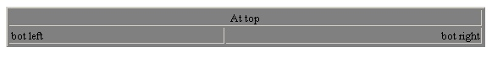

- (5 pts) Write a Javascript if statement to pop-up the alert message “Error” if the value of the variable denominator contains a 0.

- (5 pts) Use a Javascript loop to write the number 1, 2, 3, …10 on a web page. The numbers are to be displayed one per line.

- (10 pts) Write a Javascript function that
- accepts a single argument
- prompts the user for a string
- displays the string followed by the argument in an alert message

- (5 pts) Write the Javascript code to create an array named names of 3 names: “Sue”, “Joe”, and “Bob”.

- (10 pts) For each of the three buttons in the form below, explain how the mouse events work. Make sure to include how each event is triggered, the order of the events, and any potential problems:

<form>
<input type="button" value="first" onmouseover="alert('first over')" onmouseout="alert('first out')")
<br>
<input type="button" value="second" onmouseup="alert('second up')" onmousedown="alert('second down')")
<br>
<input type="button" value="third" onClick="alert('third click')" onmousemove="alert('third move')")
</form>

- (50 pts) Write a complete Javascript/HTML program that instructs the user to enter a number from 0 to 9 into a “form element”. As soon as the single character is entered (key stroke events are found in your text on page 325), your program must verify that the input number is correct. If it is not, generate an alert message and instruct the user to try again. The incorrect characters entered are to be written to a second text box. When a correct digit is entered, pop-up a new window with the appropriate image. Assume there are 10 images in a folder named “image” and they are named:
image0.jpg
image1.jpg
…
image9.jpg
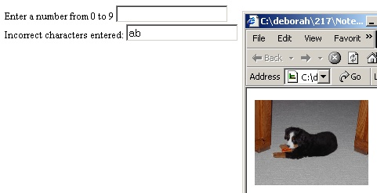

A sample of how the page would appear:

Place the completed code on the cpscsql server in the folder for this course. Name the code problem8.

