1. (5 points) Given the 2-3-4 tree shown, show EACH tree that results after inserting these numbers: 100, 5, 900, 6, and 980. Show the 4 intermediate trees and the final tree.

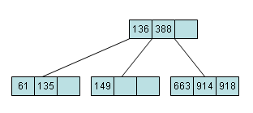
2. (5 points) Show each tree (i.e., 3 trees are needed for the answer) after deleting the numbers 136, 388, and 918 successively from the 2-3-4 tree below:

